ASSIGNMENT 2

TEAM ID: PNT2022TMID04321

Student name: EBB. Boomika

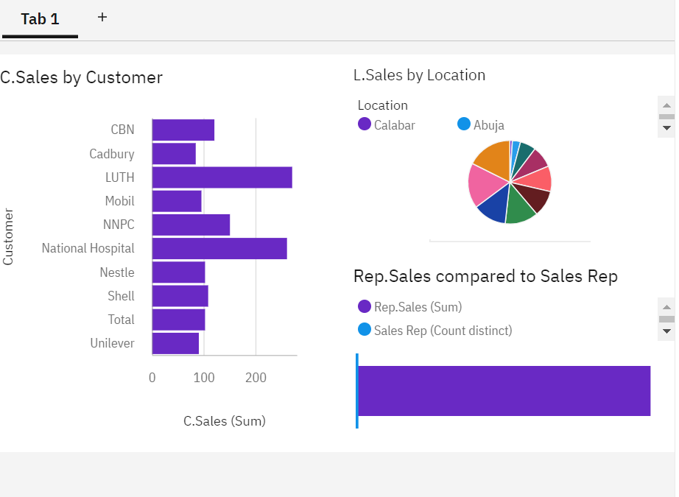

<https://us1.ca.analytics.ibm.com/bi/?perspective=dashboard&pathRef=.my_folders%2Fass2&action=view&mode=dashboard&subView=model000001837f4a02db_00000000>

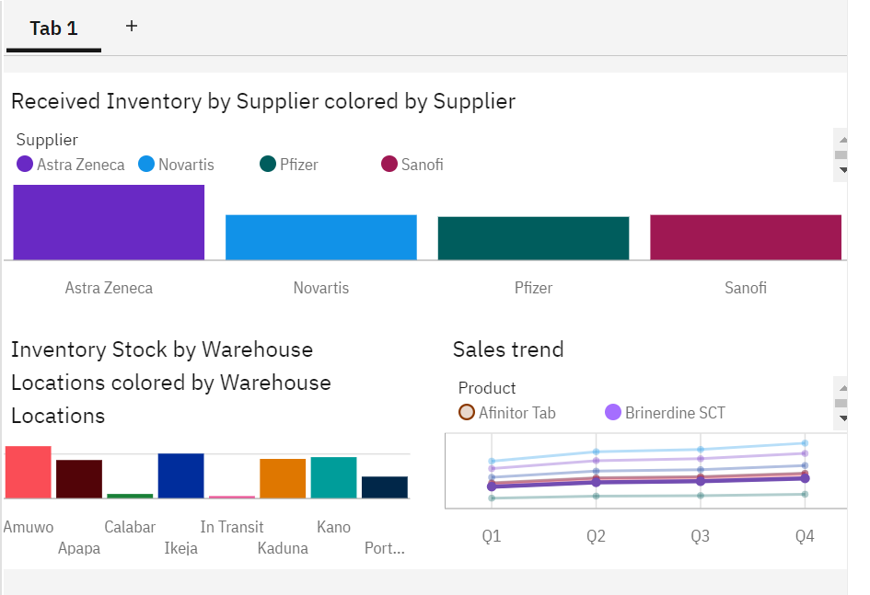

<https://us1.ca.analytics.ibm.com/bi/?perspective=dashboard&pathRef=.my_folders%2Fass2.2&action=view&mode=dashboard&subView=model000001837f58a851_00000000>

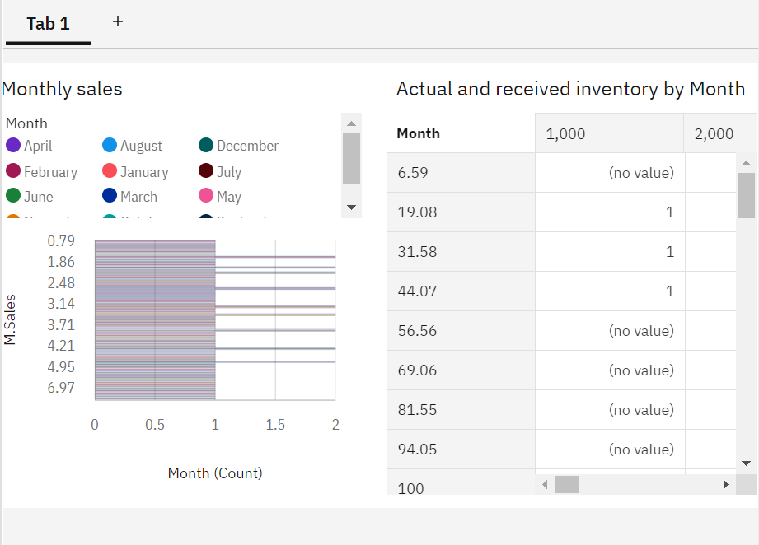

<https://us1.ca.analytics.ibm.com/bi/?perspective=dashboard&pathRef=.my_folders%2Fass2.3&action=view&mode=dashboard&subView=model000001837f613a82_00000000>